Form insurance

Setelah kita membuat class insurance maka kita lanjutkan dengan pembuatan form insurance sebagai berikut

Penampakan :

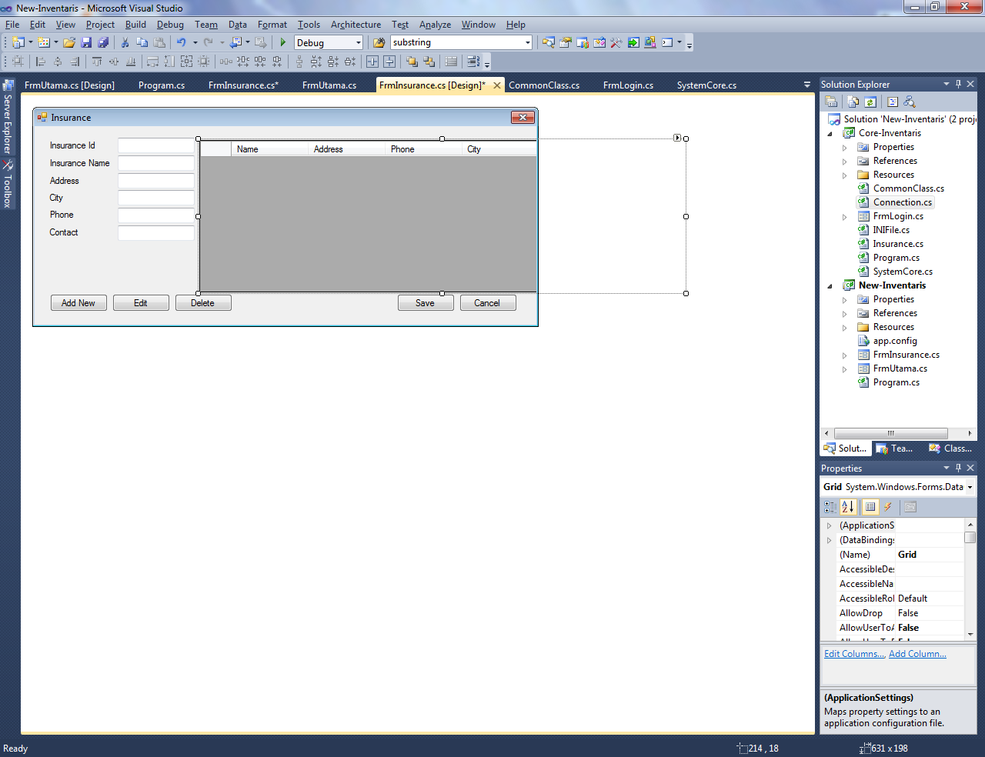

Bahan-bahan :

1. 1 buah form.
2. 1 buah datagridview.
3. 6 buah label.
4. 6 buah textbox.
5. 5 buah commandbutton.

Coding :

using System;

using System.Collections.Generic;

using System.ComponentModel;

using System.Data;

using System.Drawing;

using System.Linq;

using System.Text;

using System.Windows.Forms;

using Core_Inventaris;

namespace New_Inventaris

{

public partial class FrmInsurance : Form

{

// variable definition

Insurance Insurance = new Insurance();

Connection Connection = new Connection();

private Boolean Edit;

private string Deleted, IDx, InsuranceNamex, Addressx, Cityx, Phonex, Contactx;

public FrmInsurance()

{

InitializeComponent();

// connect to database server

if (Insurance.toServer() != true)

{

this.Close();

}

else

{

this.Grid.Location = new Point(12, 12);

refreshData();

}

Edit = false;

Grid.Focus();

Deleted = "";

}

public void refreshData()

{

// get all insurance data and display in grid

List<InsuranceData> InsDatas = new List<InsuranceData>();

InsDatas = Insurance.getData();

Grid.Rows.Clear();

foreach (var data in InsDatas)

{

Grid.Rows.Add(new string[] { data.Id, data.Name, data.Address, data.City, data.Phone, data.Contact });

}

}

public void button(bool Status)

{

// button visible

TxtId.Enabled = Status;

CmdAdd.Visible = Status;

CmdEdit.Visible = Status;

CmdDelete.Visible = Status;

Grid.Visible = Status;

CmdSave.Visible = !Status;

CmdCancel.Visible = !Status;

}

private void FrmInsurance_Load(object sender, EventArgs e)

{

button(true);

}

private void CmdAdd_Click(object sender, EventArgs e)

{

button(false);

}

private void CmdCancel_Click(object sender, EventArgs e)

{

button(true);

refreshData();

}

private void CmdDelete_Click(object sender, EventArgs e)

{

//command delete data

if (Deleted != "")

{

if (MessageBox.Show("Are sure to delete this data?", "Delete", MessageBoxButtons.OKCancel) == System.Windows.Forms.DialogResult.OK)

{

Insurance.deleteData(Deleted);

refreshData();

}

}

}

private void CmdEdit_Click(object sender, EventArgs e)

{

if (Deleted != "")

{

Edit = true;

TxtId.Text = IDx;

TxtName.Text = InsuranceNamex;

TxtAddress.Text = Addressx;

TxtCity.Text = Cityx;

TxtPhone.Text = Phonex;

TxtContact.Text = Contactx;

TxtId.Enabled = false;

button(false);

}

}

private void CmdSave_Click(object sender, EventArgs e)

{

//command save and update data

if (!Edit)

{

MessageBox.Show(Insurance.insertData(TxtId.Text, TxtName.Text, TxtAddress.Text, TxtCity.Text, TxtPhone.Text, TxtContact.Text));

}

else

{

MessageBox.Show(Insurance.updatetData(TxtId.Text, TxtName.Text, TxtAddress.Text, TxtCity.Text, TxtPhone.Text, TxtContact.Text));

}

clearField();

button(true);

}

private void Grid_CellClick(object sender, DataGridViewCellEventArgs e)

{

Deleted = Grid.Rows[e.RowIndex].Cells[0].Value.ToString();

IDx = Grid.Rows[e.RowIndex].Cells[0].Value.ToString();

InsuranceNamex = Grid.Rows[e.RowIndex].Cells[1].Value.ToString();

Addressx = Grid.Rows[e.RowIndex].Cells[2].Value.ToString();

Cityx = Grid.Rows[e.RowIndex].Cells[3].Value.ToString();

Phonex = Grid.Rows[e.RowIndex].Cells[4].Value.ToString();

Contactx = Grid.Rows[e.RowIndex].Cells[5].Value.ToString();

}

public void clearField()

{

TxtId.Text = "";

TxtName.Text = "";

TxtAddress.Text = "";

TxtCity.Text = "";

TxtPhone.Text = "";

TxtContact.Text = "";

}

}

}